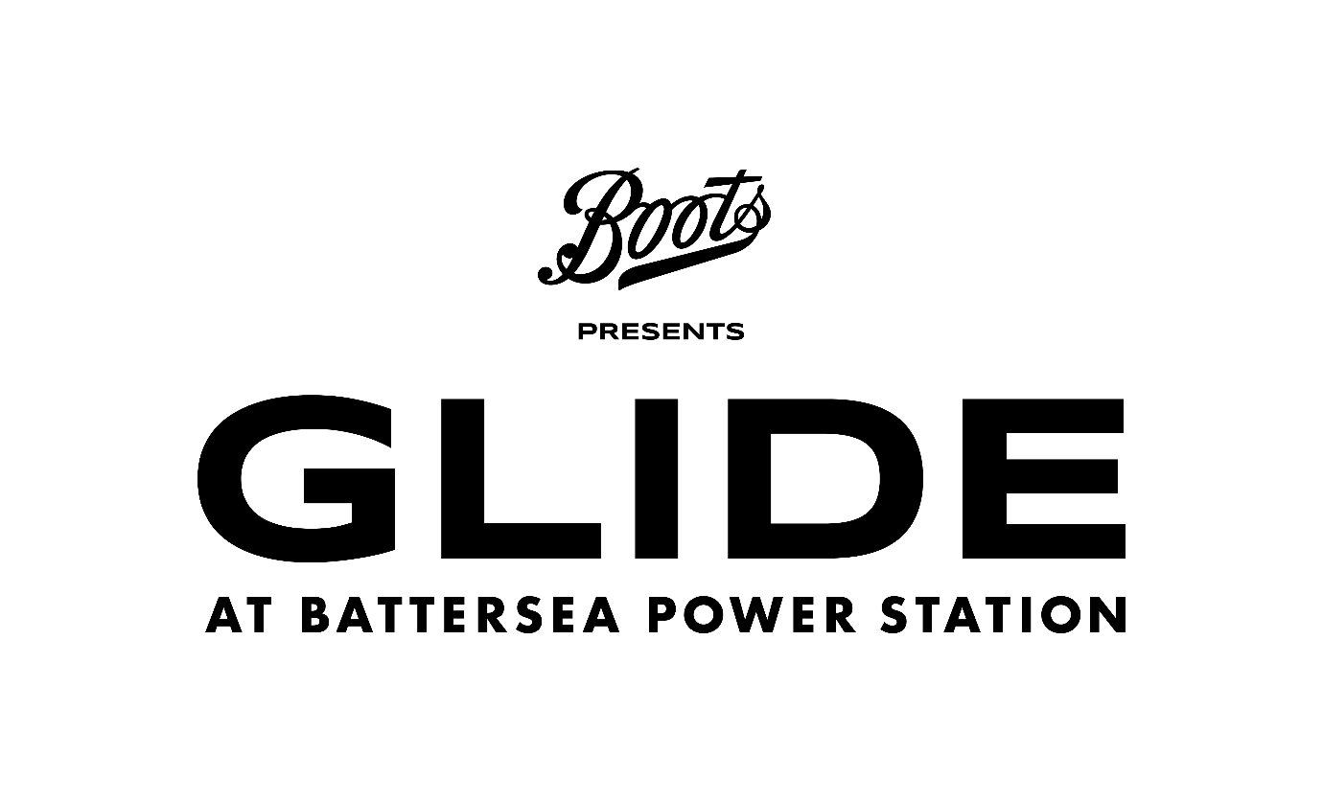

SITE DESCRIPTION
UK weather can be changeable - rain, warm temperatures and strong winds can make the surface of the ice wet. The Ice Rink is prepared for changing weather conditions, and please be assured that wet ice is safe to skate on and our experienced operational team are consistently monitoring the ice. Please check for any weather warnings on the day of your booking and, if in doubt, bring waterproof clothing.
Please see below image of the terrain across the site. If you find queuing difficult and require a faster entry to the event upon arrival with your PA, please make yourself known to a steward at the gate who will be able to look at the possibility of fast tracking your entry.
Please note that there are bag searches in operation at all our entrances.

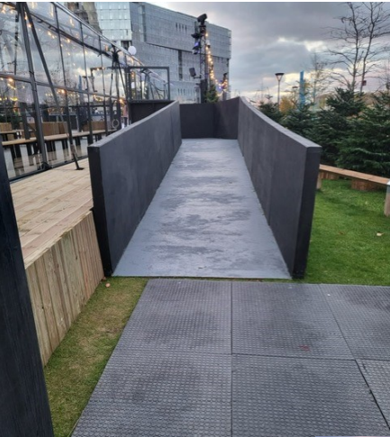
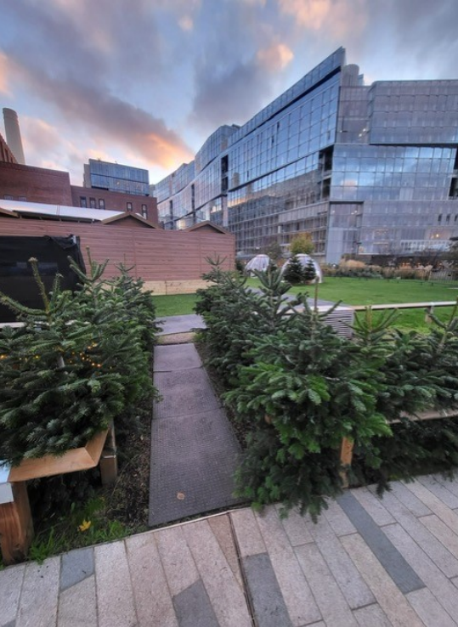
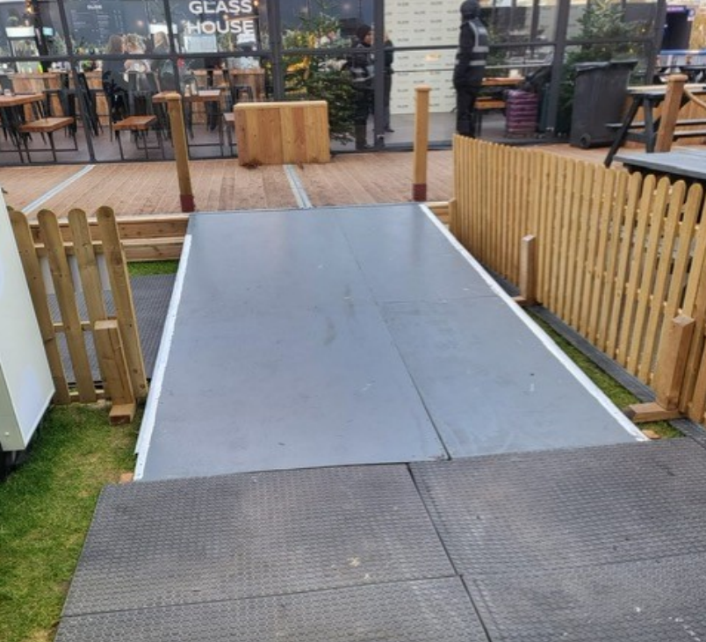
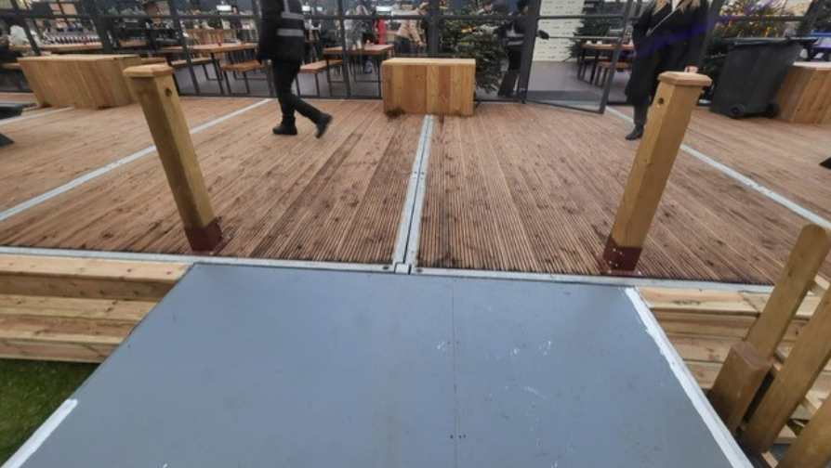
WHAT IS THE TERRAIN LIKE?

LIGHTING
Whilst there is no strobe lighting along the ice rink, some of the festive lights may include pulsating or flashing.

ESSENTIAL COMPANION TICKETS
Tickets will be provided for Companions or Personal Assistants for standard adult ticket holders who require additional assistance, at no additional cost.
For those with Child and Teen tickets, Personal Assistant ticket shall also be provided if required, at no additional cost, but the child or teen must be accompanied by a paying adult ticket holder (such adult ticket holder may be the Companion or Personal Assistant)
The above scheme and facilities are for customers with permanent/ long term access requirements and are not for people with temporary impairments such as broken bones, healing wounds or people who are pregnant. PA’s attending through this scheme must be 18 years old by the start of the event.
For further assistance please contact Universe Support via this form: https://support.universe.com/hc/en-us/requests/new All tickets subject to availability.

BOOKING TICKETS
Please select the date and time you would like to Ice Skate from the availability on our booking page.
Select the required type and number of entry tickets. Please ensure to add your free of charge Essential Companion/ Personal Assistant ticket to your booking. The Essential Companion Ticket must be added alongside a paid adult entry ticket.
You will need to present the relevant documentation at our Box Office, to pick up your Essential Companion ticket(s). This will be assessed on a case-by-case basis. Tickets will be cancelled if proof is not provided on the day.
Your tickets will be issued via your Universe Account.
Please note, if you have any questions at all about your booking, you will be able to contact Universe via this form: https://support.universe.com/hc/en-us/requests/new

RELEVANT DOCUMENTS
Examples of relevant documentation are as follows:
- DLA (Disability Living Allowance)
- PIP (Personal Independence Payment)
- Evidence of registered severely sight impaired (blind)
- CredAbility Access Card (with +1 icon)
- Copy of Attendance Allowance letter
- Recognised Assistance Dog ID card
- Any other relevant documentation

WHEELCHAIR ACCESS
All sessions are wheelchair accessible with a maximum of 6 wheelchair users per session. Please note, all electric/motorised wheelchairs must be turned off on the ice rink.

ACCESSIBLE SESSIONS
Our accessible skate sessions have a lower capacity of guests, have reduced levels of music/sound as well as lighting.

MEDICAL FACILITIES
We have first aid medical facilities onsite. If you need urgent medical attention, then please contact any member of staff.
Unfortunately, we do not have any secure storage for medicines on site.
If you have any further questions or queries, please Submit a request to our customer service team here under ‘Accessibility Information’:
https://help.glidebatterseapowerstation.co.uk/hc/en-gb/requests/new

ASSISTANCE DOGS
Glide at Battersea Power Station is committed to making sure the event is as inclusive and accessible to all and we understand that some customers will rely on an assistance dog to attend our events.
Glide at Battersea Power Station reserves the right to turn away dogs who do not comply with Assistance Dogs UK guidelines surrounding assistance dogs.
In order to ensure the smoothest entry possible, we would advise contacting our customer service team so that they can help facilitates your entry at the event and provided necessary information regarding the venue.
Please note that dogs are not permitted on the Ice Rink.

PARKING
Parking is available in Electric Boulevard (SW11 8BH) 24 hours a day.
To access the Electric Boulevard car park, enter from Battersea Park Road and drive along Pump House Lane and go down the car park ramp on the left-hand side, labelled ‘Public Car Park’.
At the bottom of the ramp, keep following the signs to the Public Car Park.
Please note, there are a limited number of spaces available and different tariffs apply

SKATE EXCHANGE
- Lowered counter at skate exchange
- Step free access via a ramp on entrance and exit
- Benches inside the skate exchange

THE GLASS HOUSE
- Step Free access via a ramp on the side nearest to Battersea Power Station
- The bar has a lowered counter.
- There will be a mix of seating options with low level and standing tables

TOILETS
There are 2 accessible toilets located at The Glass House and the skate exchange exit. The code to the lockbox to permit access to these facilities is 2002. If you have any queries please speak to a member of staff who will be able to assist.

SEATING AREAS AND VIEWING PLATFORM
- Benches inside the skate exchange
- There will be a mix of seating options with low level and standing tables
- Picnic bench seating outside
- Step free access to viewing platform by the Glass House via a ramp

RIDES
Unfortunately, the Carousel and Helter Skelter are not wheelchair accessible.
Carousel - 3-year-olds and under must be accompanied by an adult. This ride includes 3 steps to the carousel platform.
Helter Skelter - Under 6 years old or under 1m must be accompanied by an adult. Please note this ride includes multiple steps to the slide.

KEEPING YOU SAFE AND HAPPY
We understand that outdoor events can be an overwhelming experience for some of our guests who have sensory concerns or those who find noisy and busier spaces more difficult.
If you have any queries or concerns whilst at the event, please reach out to the event staff for support.

CONTACT US

If you require to visit before deciding on attending to see if the event is suitable, please contact a member of our team regarding an orientation visit and they will be able to assist
If you have any further questions or queries, please Submit a request to our customer service team here under ‘Accessibility Information’: https://help.glidebatterseapowerstation.co.uk/hc/en-gb/requests/new
You can also call our customer service team at, 02039778381, on weekdays (Monday to Friday) between 9:30 am - 5:00 pm

If you have any ticketing questions or queries, please contact Universe Support via this form: https://support.universe.com/hc/en-us/requests/new

